Lab - Researching IT and Networking Job Opportunities
Objectives
Part 1: Research Job Opportunities
Part 2: Reflect on Research
Background / Scenario
Jobs in Information Technology (IT) and computer networking continue to grow. Most employers require some form of industry standard certification, degree, or other qualifications from their potential employees, especially those with limited experience. The Cisco CCNA certification is a known and established entry-level networking certification that is respected in the industry. There are additional levels and kinds of Cisco certifications that one can attain, and each certification may enhance employment opportunities as well as salary range.
In this lab, you will complete targeted job searching on the web to find what types of IT and computer networking jobs are available; what kinds of skills and certifications you will need; and the salary ranges associated with the various job titles.
Required Resources
Device with Internet access
- Research Job Opportunities
In Part 1, you will use a web browser to visit the popular job listing websites monster.com and salary.com.
  - Open a web browser and go to a job listing website.
In the URL address bar type http://monster.com and press Enter.
Note: For job listings outside of the U.S., use the following link to search for your country:
http://www.monster.com/geo/siteselection/
  - Search for networking related jobs.
    - Type the word Network Administrator in the job title box. Click SEARCH to continue.
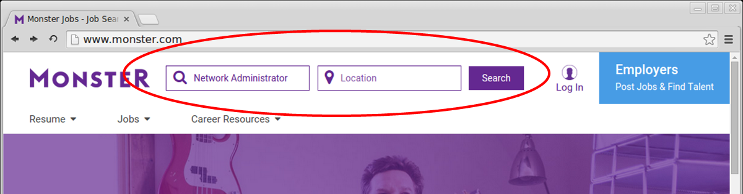
    - Notice the search results:
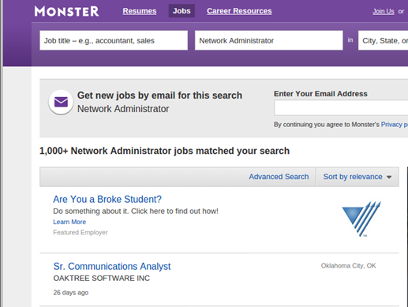
    - Now, focus your search by adding terms to the search for Network Administrator. Try terms like Cisco CCNA, CCNP, CCNA Security, CCNA Voice, etc.
    - Now try refining your search by adding different geographical locations. Did you find jobs in the locations you entered?
____________________________________________________________________________________
    - Try searching a different website. Go to http://salary.com and click the Job Search menu bar button.
Note: For salary listings outside of the U.S., use the following link to search for your country:
http://www.payscale.com/rccountries.aspx
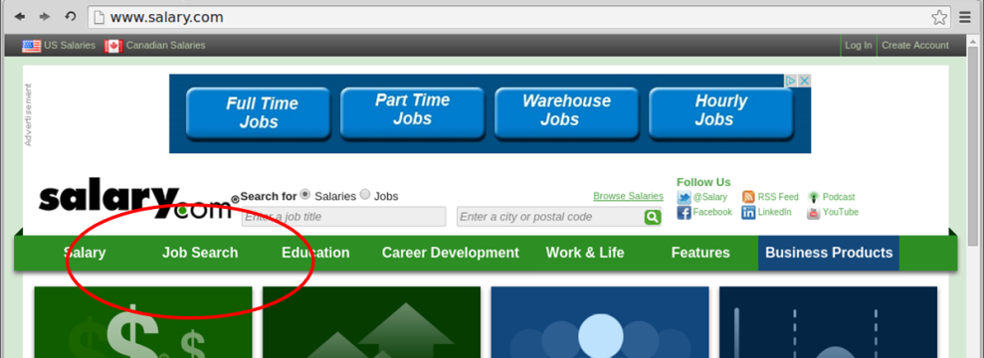
    - Add a search term like Information Technology to the job title field box and click Submit.
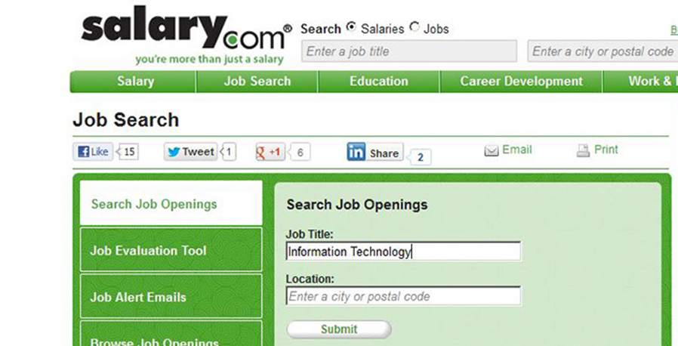
    - In the image below, note the large number of matching search results. Additional tools for refining your search are available in the left column.
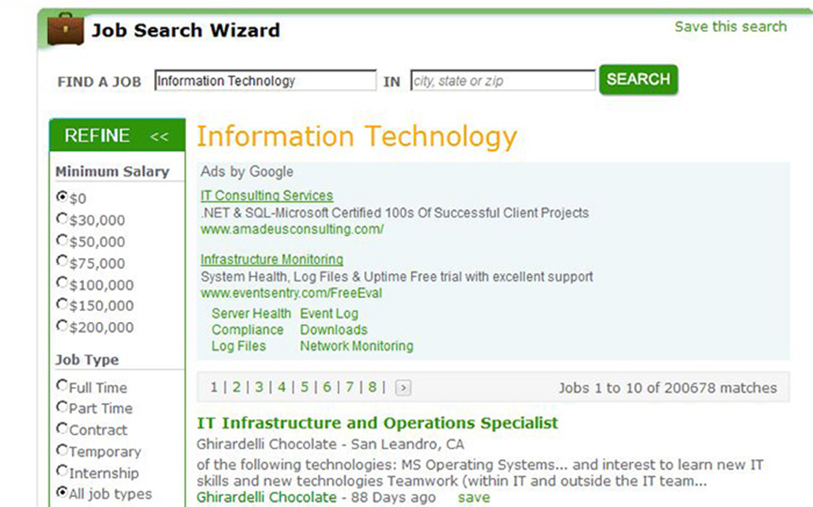
    - Spend time searching for jobs and looking through the search results. Take note of what skills are required for different job titles and the range of starting salaries.
- Reflect on Research
In Part 2, answer these questions based on your research findings.
    - What job titles did you search for?
____________________________________________________________________________________
____________________________________________________________________________________
    - What skills or certifications were required?
____________________________________________________________________________________
____________________________________________________________________________________
    - Did you find any jobs that you previously did not know existed? If so, what were they?
____________________________________________________________________________________
____________________________________________________________________________________
    - Did you find any jobs that you are interested in? If so, which ones and what skills or certifications do they require?
____________________________________________________________________________________
____________________________________________________________________________________
____________________________________________________________________________________

